**MODUL 10 PEMROGRAMAN BERORIENTASI OBJEK**

**INPUT-OUTPUT**

Seluruh source code pada modul ini tersedia pada: [Repository Github](https://github.com/afrzl/Pemrograman-Berorientasi-Objek/blob/2983b523eb51d66ece381a4518af0fb825788925/Week%2010/Praktikum)

1. **Membaca File**

Source Code:

import java.io.File;  
import java.io.FileInputStream;  
import java.io.FileNotFoundException;  
import java.io.IOException;  
import java.util.logging.Level;  
import java.util.logging.Logger;  
  
public class LatihanFile {  
 public static void main(String[] args) {  
 FileInputStream fis = null;  
 File f = new File("G:\\My Drive\\00. Tingkat 2\\Pemrograman Berorientasi Objek\\Week 10\\Praktikum\\Latihan File\\textfile.txt");  
 try {  
 fis = new FileInputStream(f);  
 while(fis.available() > 0) {  
 System.*out*.println((char) fis.read());  
 }  
   
// System.out.println(fis.available());  
// System.out.println((char) fis.read());  
// System.out.println(fis.available());  
// System.out.println((char) fis.read());  
// System.out.println(fis.available());  
 } catch (FileNotFoundException e) {  
 System.*err*.println("File tidak ditemukan");  
 } catch (IOException e) {  
 System.*err*.println("File gagal dibaca");  
 } finally {  
 try {  
 fis.close();  
 } catch (IOException ex) {  
 Logger.*getLogger*(LatihanFile.class.getName()).log(Level.*SEVERE*, null, ex);  
 }  
 }  
 }  
}

Output:

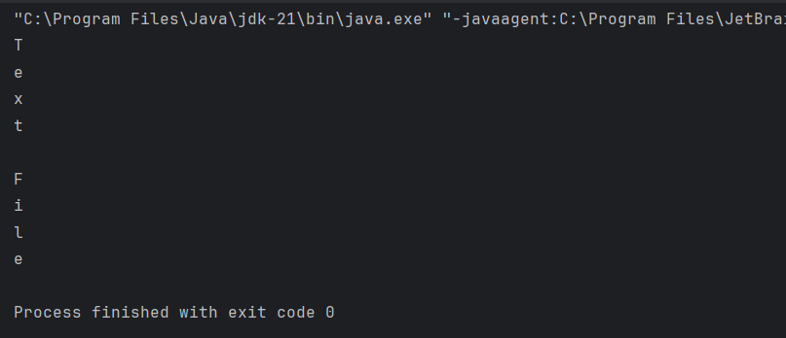

1. **Menulis File**

Source Code:

import java.io.FileNotFoundException;  
import java.io.FileOutputStream;  
import java.io.IOException;  
import java.util.logging.Level;  
import java.util.logging.Logger;  
  
public class LatihanFile {  
 public static void main(String[] args) {  
 try {  
 FileOutputStream fos = new FileOutputStream("G:\\My Drive\\00. Tingkat 2\\Pemrograman Berorientasi Objek\\Week 10\\Praktikum\\Latihan File\\javaio.txt");  
 String str = "Java Input Output";  
 fos.write(str.getBytes());  
 fos.close();  
 } catch (FileNotFoundException ex) {  
 Logger.*getLogger*(LatihanFile.class.getName()).log(Level.*SEVERE*, null, ex);  
 } catch (IOException ex) {  
 Logger.*getLogger*(LatihanFile.class.getName()).log(Level.*SEVERE*, null, ex);  
 }  
 }  
}

Output:

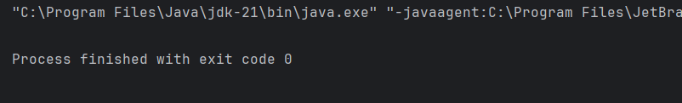

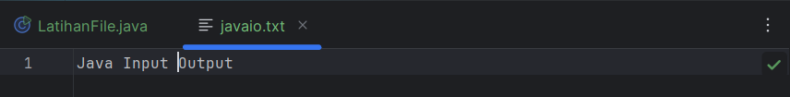

1. **GUI**

Source Code:

import javax.swing.*;  
import java.awt.*;  
import java.awt.event.*;  
import java.io.FileInputStream;  
import java.io.FileNotFoundException;  
import java.io.IOException;  
  
public class NewFrame extends JDialog {  
 private JPanel contentPane;  
 private JTextField fileTextField;  
 private JButton openButton;  
 private JScrollBar scrollBar1;  
 private JTextArea contentTextArea;  
 private JButton buttonOK;  
 private JButton buttonCancel;  
 private JFileChooser fileChooser;  
  
 public NewFrame() {  
 setContentPane(contentPane);  
 setModal(true);  
 getRootPane().setDefaultButton(buttonOK);  
 openButton.addActionListener(new ActionListener() {  
 @Override  
 public void actionPerformed(ActionEvent e) {  
 fileChooser = new JFileChooser();  
 JButton button = (JButton)e.getSource();  
 Window window = SwingUtilities.*windowForComponent*( button );  
 if (fileChooser.showOpenDialog(window) == JFileChooser.*APPROVE_OPTION*) {  
 fileTextField.setText(fileChooser.getSelectedFile().toString());  
 FileInputStream fis = null;  
 try {  
 fis = new FileInputStream(fileChooser.getSelectedFile());  
 String str = "";  
 while (fis.available() > 0) {  
 str += (char) fis.read();  
 }  
 contentTextArea.setText(str);  
 fis.close();  
 } catch (FileNotFoundException ex) {  
 System.*err*.println("File tidak ditemukan");  
 } catch (IOException ex) {  
 System.*err*.println("File gagal dibaca");  
 }  
 }  
 }  
 });  
 }  
  
 public static void main(String[] args) {  
 NewFrame dialog = new NewFrame();  
 dialog.pack();  
 dialog.setVisible(true);  
 System.*exit*(0);  
 }  
}

GUI:

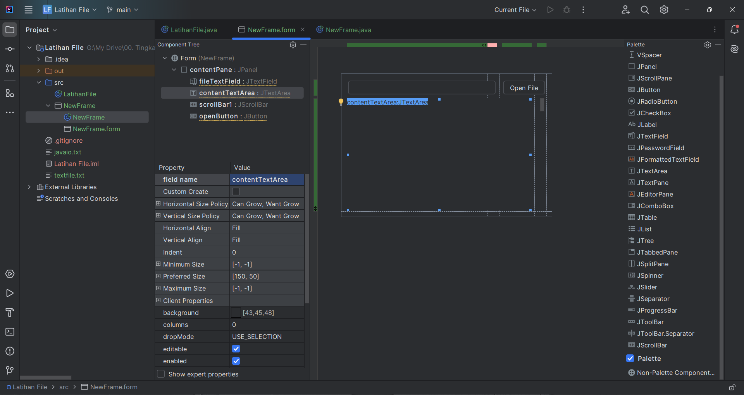

Output:

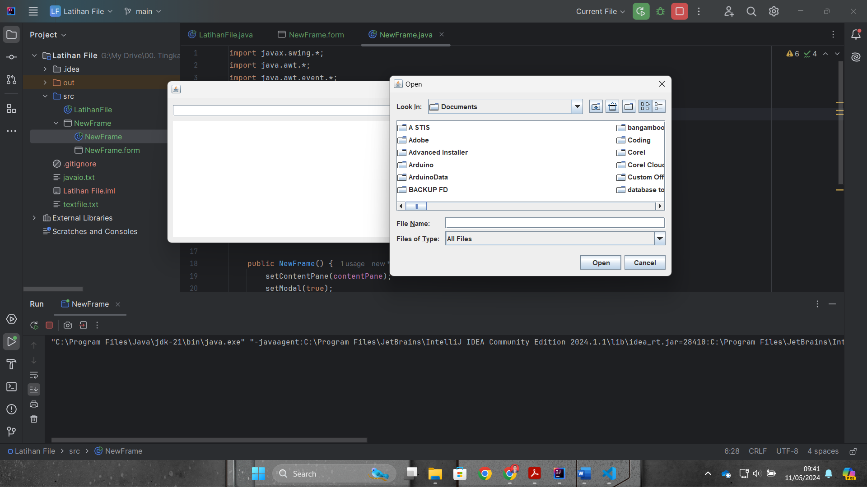

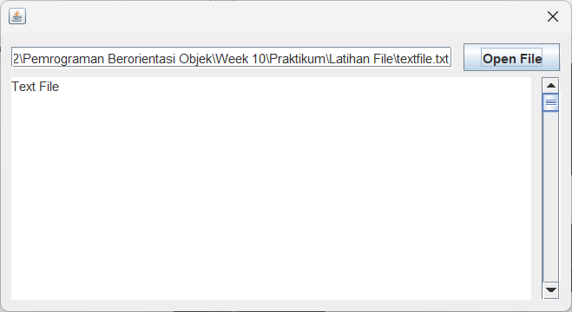

MEMBACA DAN MENULIS OBJEK

Source Code:

import java.io.FileNotFoundException;  
import java.io.FileOutputStream;  
import java.io.IOException;  
import java.io.ObjectOutputStream;  
import java.util.logging.Level;  
import java.util.logging.Logger;  
  
public class LatihanFile {  
 public static void main(String[] args) {  
 try {  
 FileOutputStream fos = new FileOutputStream("G:\\My Drive\\00. Tingkat 2\\Pemrograman Berorientasi Objek\\Week 10\\Praktikum\\Latihan File\\objek.dat");  
 ObjectOutputStream oos = new ObjectOutputStream(fos);  
 Mahasiswa mhs = new Mahasiswa();  
 mhs.setNim("1234");  
 mhs.setNama("Andi");  
 oos.writeObject(mhs);  
 oos.close();  
 fos.close();  
 } catch (FileNotFoundException ex) {  
 Logger.*getLogger*(LatihanFile.class.getName()).log(Level.*SEVERE*, null, ex);  
 } catch (IOException ex) {  
 Logger.*getLogger*(LatihanFile.class.getName()).log(Level.*SEVERE*, null, ex);  
 }  
 }  
}

Output:

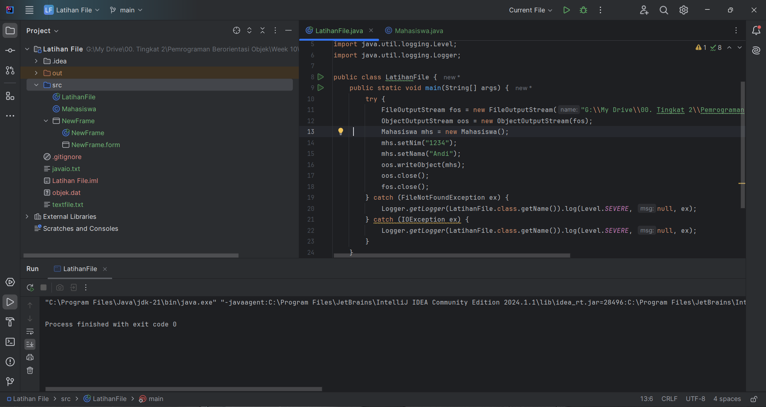

1. **Membaca Objek**

Source Code:

import java.io.*;  
  
public class LatihanFile {  
 public static void main(String[] args) {  
 try {  
 File f = new File("G:\\My Drive\\00. Tingkat 2\\Pemrograman Berorientasi Objek\\Week 10\\Praktikum\\Latihan File\\objek.dat");  
 FileInputStream fis = new FileInputStream(f);  
 ObjectInputStream ois = new ObjectInputStream(fis);  
 Mahasiswa mhs = (Mahasiswa) ois.readObject();  
 System.*out*.println(mhs.getNim());  
 System.*out*.println(mhs.getNama());  
 ois.close();  
 fis.close();  
 } catch (FileNotFoundException ex) {  
 System.*err*.println("File tidak ditemukan");  
 } catch (IOException ex) {  
 System.*err*.println("File gagal dibaca");  
 } catch (ClassNotFoundException ex) {  
 System.*err*.println("Format file salah");  
 }  
 }  
}

Output:

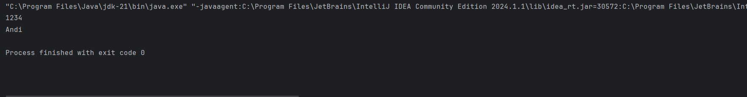

Penerapan pada LatihanGUI Modul 9

Source Code:

1. Database.java

/*  
 * Click nbfs://nbhost/SystemFileSystem/Templates/Licenses/license-default.txt to change this license  
 * Click nbfs://nbhost/SystemFileSystem/Templates/Classes/Class.java to edit this template  
 */  
package latihan.gui;  
  
import java.io.File;  
import java.io.FileInputStream;  
import java.io.FileNotFoundException;  
import java.io.FileOutputStream;  
import java.io.IOException;  
import java.io.ObjectInputStream;  
import java.io.ObjectOutputStream;  
import java.io.Serializable;  
import java.util.ArrayList;  
import java.util.List;  
import java.util.logging.Level;  
import java.util.logging.Logger;  
  
*/**  
 *  
 * @author muham  
 */*public class Database implements Serializable {  
 public static Database *instance*;  
 private ArrayList<Mahasiswa> data = new ArrayList<>();  
 private Database() {  
  
 }  
  
 public static synchronized Database getInstance() {  
 try {  
 *loadFile*();  
 } catch (IOException | ClassNotFoundException ex) {  
 Logger.*getLogger*(Database.class.getName()).log(Level.*SEVERE*, null, ex);  
 }  
 if(*instance* == null) {  
 *instance* = new Database();  
 }  
 return *instance*;  
 }  
  
 public void insertMahasiswa(Mahasiswa mahasiswa) {  
 data.add(mahasiswa);  
 updateFile();  
 }  
  
 public List<Mahasiswa> getListMahasiswa() {  
 return data;  
 }  
  
 private static void loadFile() throws IOException, ClassNotFoundException {  
 try {  
 File f = new File("G:\\My Drive\\00. Tingkat 2\\Pemrograman Berorientasi Objek\\Week 10\\Praktikum\\Latihan GUI\\database.dat");  
 FileInputStream fis = new FileInputStream(f);  
 ObjectInputStream ois = new ObjectInputStream(fis);  
 *instance* = (Database) ois.readObject();  
 ois.close();  
 fis.close();  
 } catch (FileNotFoundException ex) {  
 System.*err*.println("File tidak ditemukan");  
 } catch (IOException ex) {  
 System.*err*.println("File gagal dibaca");  
 } catch (ClassNotFoundException ex) {  
 System.*err*.println("Format File salah");  
 }  
 }  
  
 private void updateFile() {  
 try {  
 FileOutputStream fos = new FileOutputStream("G:\\My Drive\\00. Tingkat 2\\Pemrograman Berorientasi Objek\\Week 10\\Praktikum\\Latihan GUI\\database.dat");  
 ObjectOutputStream oos = new ObjectOutputStream(fos);  
 oos.writeObject(*instance*);  
 oos.close();  
 fos.close();  
 } catch (FileNotFoundException ex) {  
 System.*err*.println("File tidak ditemukan");  
 } catch (IOException ex) {  
 System.*err*.println("Gagal menulis file");  
 }  
 }  
}

1. EntryPanel.java

/*  
 * Click nbfs://nbhost/SystemFileSystem/Templates/Licenses/license-default.txt to change this license  
 * Click nbfs://nbhost/SystemFileSystem/Templates/GUIForms/JPanel.java to edit this template  
 */  
package latihan.gui;  
  
import java.util.ArrayList;  
import javax.swing.JOptionPane;  
import javax.swing.table.DefaultTableModel;  
  
*/**  
 *  
 * @author muham  
 */*public class EntryPanel extends javax.swing.JPanel {  
  
 */**  
 * Creates new form EntryPanel  
 */* public EntryPanel() {  
 initComponents();  
 loadTableData();  
 }  
  
 */**  
 * This method is called from within the constructor to initialize the form.  
 * WARNING: Do NOT modify this code. The content of this method is always  
 * regenerated by the Form Editor.  
 */* @SuppressWarnings("unchecked")  
 // <editor-fold defaultstate="collapsed" desc="Generated Code">   
 private void initComponents() {  
  
 jkButtonGroup = new javax.swing.ButtonGroup();  
 jPanel1 = new javax.swing.JPanel();  
 jLabel5 = new javax.swing.JLabel();  
 jLabel6 = new javax.swing.JLabel();  
 jScrollPane1 = new javax.swing.JScrollPane();  
 alamatTextArea = new javax.swing.JTextArea();  
 jLabel7 = new javax.swing.JLabel();  
 provinsiComboBox = new javax.swing.JComboBox<>();  
 jLabel8 = new javax.swing.JLabel();  
 membacaCheckBox = new javax.swing.JCheckBox();  
 menyanyiCheckBox = new javax.swing.JCheckBox();  
 jLabel1 = new javax.swing.JLabel();  
 jLabel2 = new javax.swing.JLabel();  
 jLabel3 = new javax.swing.JLabel();  
 nimTextField = new javax.swing.JTextField();  
 namaTextField = new javax.swing.JTextField();  
 lakiRadioButton = new javax.swing.JRadioButton();  
 perempuanRadioButton = new javax.swing.JRadioButton();  
 jLabel4 = new javax.swing.JLabel();  
 berenangCheckBox = new javax.swing.JCheckBox();  
 umurSpinner = new javax.swing.JSpinner();  
 simpanButton = new javax.swing.JButton();  
 jPanel2 = new javax.swing.JPanel();  
 jScrollPane2 = new javax.swing.JScrollPane();  
 mahasiswaTable = new javax.swing.JTable();  
  
 setLayout(new java.awt.BorderLayout());  
  
 jLabel5.setText("tahun");  
  
 jLabel6.setText("Alamat :");  
  
 alamatTextArea.setColumns(20);  
 alamatTextArea.setRows(5);  
 jScrollPane1.setViewportView(alamatTextArea);  
  
 jLabel7.setText("Provinsi :");  
  
 provinsiComboBox.setModel(new javax.swing.DefaultComboBoxModel<>(new String[] { "Aceh", "DKI Jakarta", "Jawa Timur", "Bali", "Maluku", "Papua" }));  
  
 jLabel8.setText("Hobi :");  
  
 membacaCheckBox.setText("Membaca");  
  
 menyanyiCheckBox.setText("Menyanyi");  
  
 jLabel1.setText("NIM :");  
  
 jLabel2.setText("Jenis Kelamin :");  
  
 jLabel3.setText("Nama :");  
  
 jkButtonGroup.add(lakiRadioButton);  
 lakiRadioButton.setText("Laki-laki");  
  
 jkButtonGroup.add(perempuanRadioButton);  
 perempuanRadioButton.setText("Perempuan");  
  
 jLabel4.setText("Umur :");  
  
 berenangCheckBox.setText("Berenang");  
  
 umurSpinner.setModel(new javax.swing.SpinnerNumberModel(15, 10, 60, 1));  
  
 simpanButton.setText("Simpan");  
 simpanButton.addActionListener(new java.awt.event.ActionListener() {  
 public void actionPerformed(java.awt.event.ActionEvent evt) {  
 simpanButtonActionPerformed(evt);  
 }  
 });  
  
 javax.swing.GroupLayout jPanel1Layout = new javax.swing.GroupLayout(jPanel1);  
 jPanel1.setLayout(jPanel1Layout);  
 jPanel1Layout.setHorizontalGroup(  
 jPanel1Layout.createParallelGroup(javax.swing.GroupLayout.Alignment.*LEADING*)  
 .addGap(0, 342, Short.*MAX_VALUE*)  
 .addGroup(jPanel1Layout.createParallelGroup(javax.swing.GroupLayout.Alignment.*LEADING*)  
 .addGroup(jPanel1Layout.createSequentialGroup()  
 .addGap(13, 13, 13)  
 .addGroup(jPanel1Layout.createParallelGroup(javax.swing.GroupLayout.Alignment.*TRAILING*)  
 .addComponent(simpanButton)  
 .addGroup(jPanel1Layout.createSequentialGroup()  
 .addGroup(jPanel1Layout.createParallelGroup(javax.swing.GroupLayout.Alignment.*LEADING*, false)  
 .addComponent(jLabel1, javax.swing.GroupLayout.*DEFAULT_SIZE*, javax.swing.GroupLayout.*DEFAULT_SIZE*, Short.*MAX_VALUE*)  
 .addComponent(jLabel2, javax.swing.GroupLayout.*DEFAULT_SIZE*, javax.swing.GroupLayout.*DEFAULT_SIZE*, Short.*MAX_VALUE*)  
 .addComponent(jLabel3, javax.swing.GroupLayout.Alignment.*TRAILING*, javax.swing.GroupLayout.*DEFAULT_SIZE*, 83, Short.*MAX_VALUE*)  
 .addComponent(jLabel4, javax.swing.GroupLayout.*DEFAULT_SIZE*, javax.swing.GroupLayout.*DEFAULT_SIZE*, Short.*MAX_VALUE*)  
 .addComponent(jLabel6, javax.swing.GroupLayout.Alignment.*TRAILING*, javax.swing.GroupLayout.*DEFAULT_SIZE*, javax.swing.GroupLayout.*DEFAULT_SIZE*, Short.*MAX_VALUE*)  
 .addComponent(jLabel7, javax.swing.GroupLayout.*DEFAULT_SIZE*, javax.swing.GroupLayout.*DEFAULT_SIZE*, Short.*MAX_VALUE*)  
 .addComponent(jLabel8, javax.swing.GroupLayout.*DEFAULT_SIZE*, javax.swing.GroupLayout.*DEFAULT_SIZE*, Short.*MAX_VALUE*))  
 .addPreferredGap(javax.swing.LayoutStyle.ComponentPlacement.*RELATED*)  
 .addGroup(jPanel1Layout.createParallelGroup(javax.swing.GroupLayout.Alignment.*LEADING*)  
 .addComponent(berenangCheckBox, javax.swing.GroupLayout.*PREFERRED_SIZE*, 85, javax.swing.GroupLayout.*PREFERRED_SIZE*)  
 .addComponent(menyanyiCheckBox, javax.swing.GroupLayout.*PREFERRED_SIZE*, 85, javax.swing.GroupLayout.*PREFERRED_SIZE*)  
 .addGroup(jPanel1Layout.createParallelGroup(javax.swing.GroupLayout.Alignment.*LEADING*, false)  
 .addComponent(perempuanRadioButton, javax.swing.GroupLayout.*PREFERRED_SIZE*, 98, javax.swing.GroupLayout.*PREFERRED_SIZE*)  
 .addComponent(lakiRadioButton, javax.swing.GroupLayout.*PREFERRED_SIZE*, 98, javax.swing.GroupLayout.*PREFERRED_SIZE*)  
 .addComponent(namaTextField, javax.swing.GroupLayout.*DEFAULT_SIZE*, 154, Short.*MAX_VALUE*)  
 .addComponent(nimTextField))  
 .addGroup(jPanel1Layout.createSequentialGroup()  
 .addComponent(umurSpinner, javax.swing.GroupLayout.*PREFERRED_SIZE*, javax.swing.GroupLayout.*DEFAULT_SIZE*, javax.swing.GroupLayout.*PREFERRED_SIZE*)  
 .addPreferredGap(javax.swing.LayoutStyle.ComponentPlacement.*RELATED*)  
 .addComponent(jLabel5, javax.swing.GroupLayout.*PREFERRED_SIZE*, 39, javax.swing.GroupLayout.*PREFERRED_SIZE*))  
 .addComponent(jScrollPane1, javax.swing.GroupLayout.*PREFERRED_SIZE*, javax.swing.GroupLayout.*DEFAULT_SIZE*, javax.swing.GroupLayout.*PREFERRED_SIZE*)  
 .addComponent(provinsiComboBox, javax.swing.GroupLayout.*PREFERRED_SIZE*, 92, javax.swing.GroupLayout.*PREFERRED_SIZE*)  
 .addComponent(membacaCheckBox, javax.swing.GroupLayout.*PREFERRED_SIZE*, 85, javax.swing.GroupLayout.*PREFERRED_SIZE*))))  
 .addContainerGap(javax.swing.GroupLayout.*DEFAULT_SIZE*, Short.*MAX_VALUE*)))  
 );  
 jPanel1Layout.setVerticalGroup(  
 jPanel1Layout.createParallelGroup(javax.swing.GroupLayout.Alignment.*LEADING*)  
 .addGap(0, 439, Short.*MAX_VALUE*)  
 .addGroup(jPanel1Layout.createParallelGroup(javax.swing.GroupLayout.Alignment.*LEADING*)  
 .addGroup(jPanel1Layout.createSequentialGroup()  
 .addContainerGap()  
 .addGroup(jPanel1Layout.createParallelGroup(javax.swing.GroupLayout.Alignment.*BASELINE*)  
 .addComponent(jLabel1)  
 .addComponent(nimTextField, javax.swing.GroupLayout.*PREFERRED_SIZE*, javax.swing.GroupLayout.*DEFAULT_SIZE*, javax.swing.GroupLayout.*PREFERRED_SIZE*))  
 .addPreferredGap(javax.swing.LayoutStyle.ComponentPlacement.*UNRELATED*)  
 .addGroup(jPanel1Layout.createParallelGroup(javax.swing.GroupLayout.Alignment.*BASELINE*)  
 .addComponent(jLabel3)  
 .addComponent(namaTextField, javax.swing.GroupLayout.*PREFERRED_SIZE*, javax.swing.GroupLayout.*DEFAULT_SIZE*, javax.swing.GroupLayout.*PREFERRED_SIZE*))  
 .addPreferredGap(javax.swing.LayoutStyle.ComponentPlacement.*UNRELATED*)  
 .addGroup(jPanel1Layout.createParallelGroup(javax.swing.GroupLayout.Alignment.*BASELINE*)  
 .addComponent(jLabel2)  
 .addComponent(lakiRadioButton))  
 .addPreferredGap(javax.swing.LayoutStyle.ComponentPlacement.*RELATED*)  
 .addComponent(perempuanRadioButton)  
 .addPreferredGap(javax.swing.LayoutStyle.ComponentPlacement.*RELATED*)  
 .addGroup(jPanel1Layout.createParallelGroup(javax.swing.GroupLayout.Alignment.*BASELINE*)  
 .addComponent(jLabel4)  
 .addComponent(umurSpinner, javax.swing.GroupLayout.*PREFERRED_SIZE*, javax.swing.GroupLayout.*DEFAULT_SIZE*, javax.swing.GroupLayout.*PREFERRED_SIZE*)  
 .addComponent(jLabel5))  
 .addPreferredGap(javax.swing.LayoutStyle.ComponentPlacement.*UNRELATED*)  
 .addGroup(jPanel1Layout.createParallelGroup(javax.swing.GroupLayout.Alignment.*LEADING*)  
 .addComponent(jLabel6)  
 .addComponent(jScrollPane1, javax.swing.GroupLayout.*PREFERRED_SIZE*, javax.swing.GroupLayout.*DEFAULT_SIZE*, javax.swing.GroupLayout.*PREFERRED_SIZE*))  
 .addGap(7, 7, 7)  
 .addGroup(jPanel1Layout.createParallelGroup(javax.swing.GroupLayout.Alignment.*BASELINE*)  
 .addComponent(jLabel7)  
 .addComponent(provinsiComboBox, javax.swing.GroupLayout.*PREFERRED_SIZE*, javax.swing.GroupLayout.*DEFAULT_SIZE*, javax.swing.GroupLayout.*PREFERRED_SIZE*))  
 .addPreferredGap(javax.swing.LayoutStyle.ComponentPlacement.UNRELATED)  
 .addGroup(jPanel1Layout.createParallelGroup(javax.swing.GroupLayout.Alignment.LEADING)  
 .addComponent(jLabel8)  
 .addComponent(membacaCheckBox))  
 .addPreferredGap(javax.swing.LayoutStyle.ComponentPlacement.RELATED)  
 .addComponent(menyanyiCheckBox)  
 .addPreferredGap(javax.swing.LayoutStyle.ComponentPlacement.RELATED)  
 .addComponent(berenangCheckBox)  
 .addGap(18, 18, 18)  
 .addComponent(simpanButton)  
 .addContainerGap(37, Short.MAX_VALUE)))  
 );  
  
 add(jPanel1, java.awt.BorderLayout.LINE_START);  
  
 mahasiswaTable.setModel(new javax.swing.table.DefaultTableModel(  
 new Object [][] {  
  
 },  
 new String [] {  
 "NIM", "Nama", "Jenis Kelamin", "Umur"  
 }  
 ) {  
 Class[] types = new Class [] {  
 java.lang.String.class, java.lang.String.class, java.lang.String.class, java.lang.Integer.class  
 };  
 boolean[] canEdit = new boolean [] {  
 false, false, false, false  
 };  
  
 public Class getColumnClass(int columnIndex) {  
 return types [columnIndex];  
 }  
  
 public boolean isCellEditable(int rowIndex, int columnIndex) {  
 return canEdit [columnIndex];  
 }  
 });  
 jScrollPane2.setViewportView(mahasiswaTable);  
  
 javax.swing.GroupLayout jPanel2Layout = new javax.swing.GroupLayout(jPanel2);  
 jPanel2.setLayout(jPanel2Layout);  
 jPanel2Layout.setHorizontalGroup(  
 jPanel2Layout.createParallelGroup(javax.swing.GroupLayout.Alignment.LEADING)  
 .addGap(0, 467, Short.MAX_VALUE)  
 .addGroup(jPanel2Layout.createParallelGroup(javax.swing.GroupLayout.Alignment.LEADING)  
 .addGroup(javax.swing.GroupLayout.Alignment.TRAILING, jPanel2Layout.createSequentialGroup()  
 .addContainerGap(9, Short.MAX_VALUE)  
 .addComponent(jScrollPane2, javax.swing.GroupLayout.PREFERRED_SIZE, javax.swing.GroupLayout.DEFAULT_SIZE, javax.swing.GroupLayout.PREFERRED_SIZE)  
 .addContainerGap()))  
 );  
 jPanel2Layout.setVerticalGroup(  
 jPanel2Layout.createParallelGroup(javax.swing.GroupLayout.Alignment.LEADING)  
 .addGap(0, 439, Short.MAX_VALUE)  
 .addGroup(jPanel2Layout.createParallelGroup(javax.swing.GroupLayout.Alignment.LEADING)  
 .addGroup(jPanel2Layout.createSequentialGroup()  
 .addContainerGap()  
 .addComponent(jScrollPane2, javax.swing.GroupLayout.PREFERRED_SIZE, javax.swing.GroupLayout.DEFAULT_SIZE, javax.swing.GroupLayout.PREFERRED_SIZE)  
 .addContainerGap(javax.swing.GroupLayout.DEFAULT_SIZE, Short.MAX_VALUE)))  
 );  
  
 add(jPanel2, java.awt.BorderLayout.CENTER);  
 }// </editor-fold>   
  
 private void simpanButtonActionPerformed(java.awt.event.ActionEvent evt) {  
 // TODO add your handling code here:  
 Mahasiswa mhs = new Mahasiswa();  
 mhs.setNim(nimTextField.getText());  
 mhs.setNama(namaTextField.getText());  
 if(lakiRadioButton.isSelected()) {  
 mhs.setJenisKelamin("Laki-laki");  
 }  
 if(perempuanRadioButton.isSelected()) {  
 mhs.setJenisKelamin("Perempuan");  
 }  
 int umur = (Integer) umurSpinner.getValue();  
 mhs.setUmur(umur);  
 mhs.setAlamat(alamatTextArea.getText());  
  
 mhs.setProvinsi(provinsiComboBox.getSelectedItem().toString());  
 ArrayList<String> hobiList = new ArrayList<>();  
 if(membacaCheckBox.isSelected()) {  
 hobiList.add("membaca");  
 }  
 if(menyanyiCheckBox.isSelected()) {  
 hobiList.add("menyanyi");  
 }  
 if(berenangCheckBox.isSelected()) {  
 hobiList.add("berenang");  
 }  
 mhs.setHobi(hobiList);  
 Database.getInstance().insertMahasiswa(mhs);  
  
 clearForm();  
 JOptionPane.showMessageDialog(this, "Sukses Tersimpan");  
 loadTableData();  
 }  
  
 private void loadTableData() {  
 DefaultTableModel dtm = (DefaultTableModel) mahasiswaTable.getModel();  
  
 //refresh table  
 while(dtm.getRowCount() > 0) {  
 dtm.removeRow(0);  
 }  
  
 //isi tabel  
 for(Mahasiswa mhs : Database.getInstance().getListMahasiswa()) {  
 dtm.addRow(new Object[]{mhs.getNim(), mhs.getNama(), mhs.getJenisKelamin(), mhs.getUmur()});  
 }  
 }  
  
 private void clearForm() {  
 nimTextField.setText("");  
 namaTextField.setText("");  
 jkButtonGroup.clearSelection();  
 umurSpinner.setValue(15);  
 alamatTextArea.setText("");  
 provinsiComboBox.setSelectedItem(-1);  
 membacaCheckBox.setSelected(false);  
 menyanyiCheckBox.setSelected(false);  
 berenangCheckBox.setSelected(false);  
 }  
  
  
 // Variables declaration - do not modify   
 private javax.swing.JTextArea alamatTextArea;  
 private javax.swing.JCheckBox berenangCheckBox;  
 private javax.swing.JLabel jLabel1;  
 private javax.swing.JLabel jLabel2;  
 private javax.swing.JLabel jLabel3;  
 private javax.swing.JLabel jLabel4;  
 private javax.swing.JLabel jLabel5;  
 private javax.swing.JLabel jLabel6;  
 private javax.swing.JLabel jLabel7;  
 private javax.swing.JLabel jLabel8;  
 private javax.swing.JPanel jPanel1;  
 private javax.swing.JPanel jPanel2;  
 private javax.swing.JScrollPane jScrollPane1;  
 private javax.swing.JScrollPane jScrollPane2;  
 private javax.swing.ButtonGroup jkButtonGroup;  
 private javax.swing.JRadioButton lakiRadioButton;  
 private javax.swing.JTable mahasiswaTable;  
 private javax.swing.JCheckBox membacaCheckBox;  
 private javax.swing.JCheckBox menyanyiCheckBox;  
 private javax.swing.JTextField namaTextField;  
 private javax.swing.JTextField nimTextField;  
 private javax.swing.JRadioButton perempuanRadioButton;  
 private javax.swing.JComboBox<String> provinsiComboBox;  
 private javax.swing.JButton simpanButton;  
 private javax.swing.JSpinner umurSpinner;  
 // End of variables declaration   
}

Output:

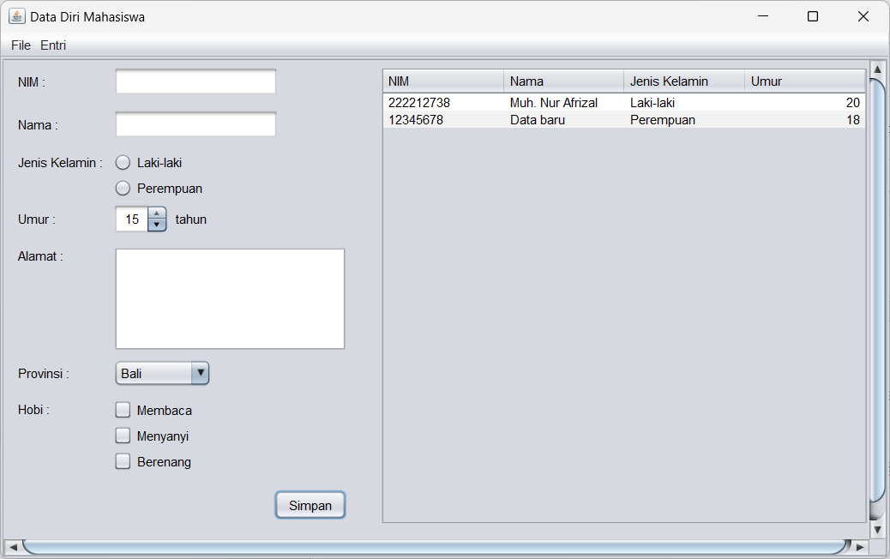

Setelah di*close* lalu dibuka kembali:

